**CS550 – Advanced Operating Systems**

**Design Document**

**Decentralized File Sharing System**

**Adithya Sreenath Chandrashekarapuram** **A20402135**

**Overview**

This program aims to develop a Decentralized Napster style file sharing system, through the integration of my centralized file sharing system and a distributed index table. There are several indexing servers which are decentralized. Indexing servers index the contents of the peers that register with them. They also provide search facility to peer and an option to download files from peers

**Design**

1. There are 8 peers and 8 index servers in the system.
2. All the peers and the index servers will be running on the same machine.
3. There is a config file provided which allows the users to change the port numbers based on his requirements.
4. The files will be stored on the index servers based on the name of the file.
5. Each peer must first register the files with the indexing servers.

* The peers are asked to specify the filename and the peer name from which the file is being registered.
* The file name is passed to a hash function which returns a number between 1 to 8.
* Based on the number the file is stored in the index server of that value.
* The files are stored in a python dictionary which gets updated upon each registration of a file.
* The peers are allowed to register multiple files at once if required.

1. The peers are allowed to search for the files

* The user needs to specify the filename to search for the file
* Upon specifying the file name the hash function is called and returns a number from 1 to 8.
* Based on the hash value we can locate the index server where the file is stored and retrieve it for the peer.
* Multiple searches can be performed simultaneously

1. The peers are allowed to download files

* The peer must specify the peer name and the file name from which they wish to download
* The file is then copied into the directory of the peer which requested the file.
* The peer is not allowed to download a file from itself.
* Multiple downloads can be done at once.
* Large files take longer to download so small size files have been used.

**Architecture**

This is the architecture for 3 peers with 3 index servers but can be scaled up further.

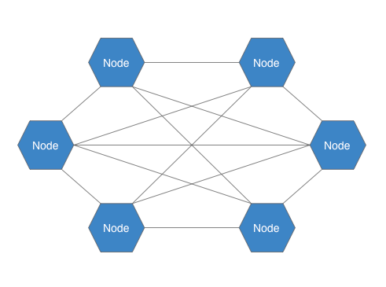

Peer2

Index 1

Peer1

Peer3

Index 2

Index 3

**Future Enhancements**

1. A file transfer protocol can be implemented for downloads
2. The program can be done to run over multiple devices instead of a single device.
3. Implementation of a GUI.
4. Increasing the number of peers and index servers.
5. Allowing for encryption of data to improve security while transferring files.